**Environmental stimuli**

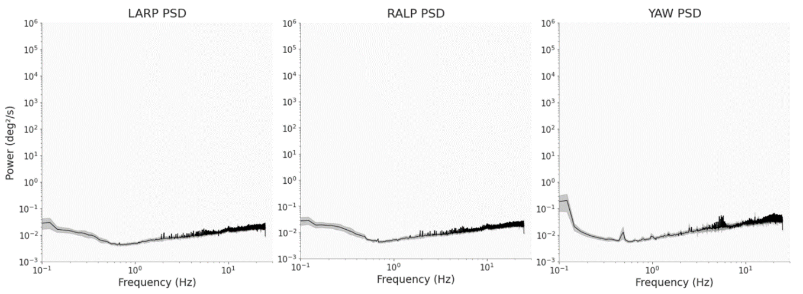

Supplementary Figure 3: Population-averaged power spectra of the environmental motion velocity signal projected in the LARP, RALP and YAW planes, with corresponding 95% confidence interval (shaded areas) during the simulated flight.

We wondered whether the peak present in the power spectra during the manual navigation task could have been caused by some external resonant element in the immediate vicinity of the pilots. To assess the potentially nefarious effects of vibrations stemming from the helicopter simulator, we computed the power spectrum of the velocity signal from an IMU attached to the roof of the cabin (Supplementary Figure 3). The power spectra strongly differed from the ones measured at the participant’s head: they lacked the inverted ‘U’ shape, and the power appeared to be nearly constant over the whole frequency range. Thus, the aforementioned peak does not seem to be generated by mechanical vibrations of the cabin, at the scale of the cabin.

We note that, contrary to [2], the frequency content of the environmental stimuli does not follow a single power law. We attribute this discrepancy in the shape of the power spectra to the atypical nature of our environmental stimuli: movements of the cabin correspond to rotations and translations of a helicopter cabin, in a motorized simulator, driven by actions on the commands translated into a set of angular displacements constrained by the physical limitations of the simulator. Hence, pilots experience environmental stimuli that strongly differ from “white noise”.